Preventing future Malware, Spyware, Adware Problems

Almost every threat on your computer today comes in because of this little question. Answer it wrong and you are infected with weird toolbars, popups, slowdowns, your internet access becomes crippled and worse. This document was written to show you how you are getting the bad stuff and how to prevent it. The question presented below, what does it mean? In a nutshell, the question below a lot of times means the web site you are visiting is asking you if you want to install something from their website. If you know the web site is trustworthy, you may answer the question “Yes”. If you don’t know answer “No”. But in any case, never check the box that states, “In the future, don’t show this message”. Why? Because if you answer this question “Yes” and never ask me again, you are telling Internet Explorer (your browser you using to get to the internet) Permanently allow everyone from this point forward to install junk on my computer without asking me anymore if I just visit their website. See, there are many websites that are setup to install software on your computer automatically. Just visiting these websites (not even clicking on anything on the website) can get you infected, or toolbars you didn’t ask for. So when you see this question, know what it means and how to answer it wisely.
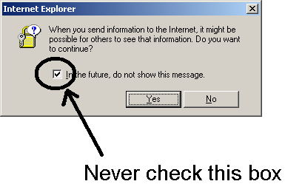
Answer Yes if you trust the web site you are on.
Answer No if you do not trust the web site.

NEVER CHECK THE “In the future, do not show this message” box

If you answered yes on accident, or if you want to reset all questions back to asking you again, do the following:

To reset your Internet Explorer back to defaults do the following:
Control Panel
Internet Options
Click the Security Tab
Highlight “Internet” (The world icon)
Click the “Default Level” button
Highlight “Local intranet” (The world icon is behind a computer)
Click the “Default Level” button
Highlight “Trusted sites” (The green check icon)
Click the “Default Level” button
Highlight “Restricted sites” (The red circle icon)
Click the “Default Level” button
Click the Programs Tab
Click the “Reset Web Settings” button (You may see a message about resetting your home page. You can uncheck “Also reset my home page” if your home page is what you want it to be (otherwise it will be reset to www.msn.com) In both cases, answer “Yes”
(Your Web settings have been reset to their original Internet Explorer defaults) Click OK.
Click the Advanced Tab
Click “Restore Defaults” (No message or anything will happen)
Now Click OK
Close the Control Panel

