Allowing others to connect to my Consolidated wireless network

Step 1
Go to the computer you want to have access
Click Start
Click Run
Type what is between these brackets [ cmd ] and Click OK
Type this [ ipconfig /all ] and press Enter

Look below at the example
Write down the Physical Address (You may have more than one, but the only one that matters is under the Wireless section)
========================================================
Wireless Ethernet adapter Local Area Connection:

Connection-specific DNS Suffix . : aol.com
Description . . . . . . . . . . . : Linksys LNE100TX Wireless Ethernet Adapter
Physical Address. . . . . . . . . : 00-12-17-5B-BE-DD
Dhcp Enabled. . . . . . . . . . . : Yes
Autoconfiguration Enabled . . . . : Yes
IP Address. . . . . . . . . . . . : 192.168.0.101
Subnet Mask . . . . . . . . . . . : 255.255.255.0
Default Gateway . . . . . . . . . : 192.168.0.1
DHCP Server . . . . . . . . . . . : 192.168.0.1
DNS Servers . . . . . . . . . . . : 192.168.0.1
Lease Obtained. . . . . . . . . . : Monday, December 19, 2005 10:49:40 AM
Lease Expires . . . . . . . . . . : Monday, December 26, 2005 10:49:40 AM
========================================================

Your PDA, PSP, WiFi Phone, Printer, or other device may have the MAC Address on the device behind the battery or on the back of the device or card.

Step 2
Go to a computer that is already connected and working on the Internet
Click on Start
Click on Run
Type in [ iexplore 192.168.1.1 ] and click OK
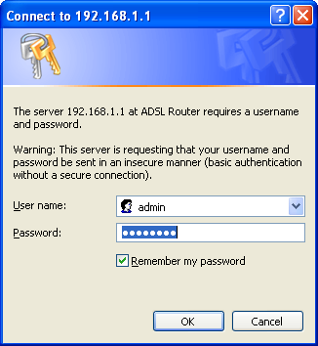
Type in [ admin ] as the User name
Type in [ cciadmin ] as the password
Your password may be different
Click Wireless
Click Wireless MAC Filter (next line down)
Click Add
Put the Physical Address you wrote down earlier in an empty MAC Address box
*** USE COLONS NOT DASHES ***
Scroll to the bottom and choose Save Settings
It should be on the list now
Click the “X”
Close everything, reboot the computer that needed wireless and try to get in.

