Enabling a computer so others can access it

Control Panel
Administrative Tools
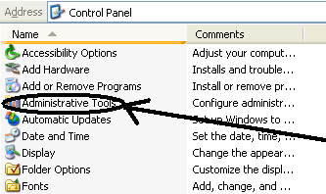

Local Security Policy
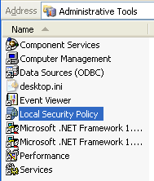

Under Security Settings, Local Policies, highlight Security Options
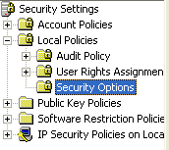

On the right window change the following
Microsoft network server: Amount of idle time…Change it from 15 to 0
Network access: Let Everyone permissions apply…Change it from Disabled to Enabled

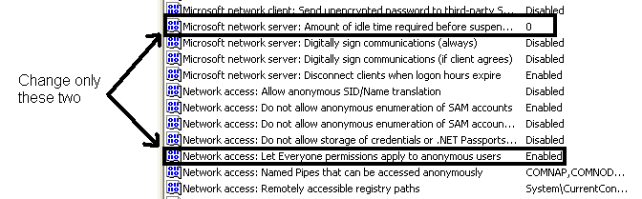

If you don’t do this and you may be prompted again and again for a name and password on the remote computer.

